Incident response | MSP-07
Maintenance System Procedure | MSP-07
This procedure describes the tasks involved in responding to incidents.
All incidents are recorded on the Incident Register in Reflect. The Incident Register generates a unique number for each entry
Incidents include:
(a) Attend to Traffic Incident (Activity 801) - Includes traffic accidents, removal of abandoned or unattended vehicles.
(b) Weather Related Incident (Activity 802) - Includes flooding across road, storm damage, fires, etc.
(c) Other Incidents (Activity 803) - Includes vandalism damage, structure failures such as culvert or a bridge, rock falls and land slips.
(d) Recoverable Works (Activity 804) - Includes works where the cost of repair can be recovered from a third-party.
Local areas may have more detailed procedures as needed.
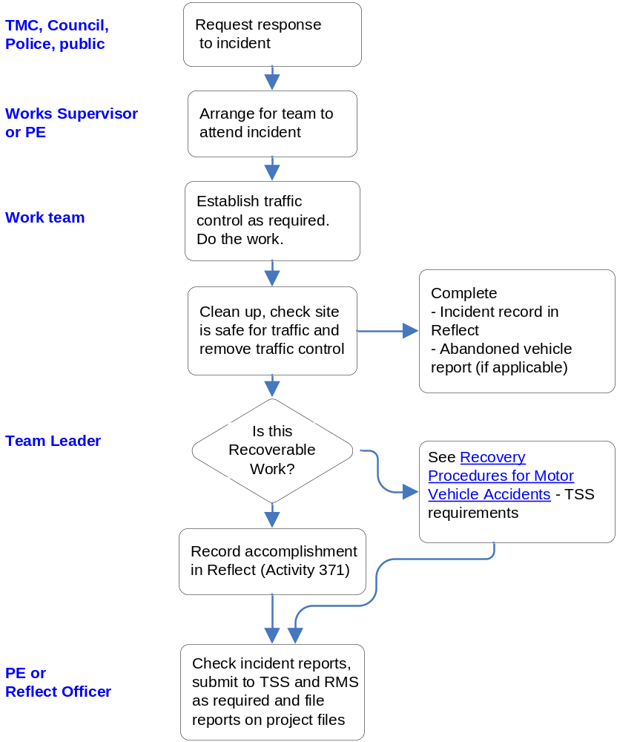
Complete H7 Incident Form & H9 Incident Costing Form

TfNSW, TMC, Police, Public

On-call Staff/Overseer

Work Team

Overseer

Project Coordinator

Check Incident reports, submit to TSS and TfNSW as required and file reports on project files
Emergency planning and response
In responding to an emergency:
- Advise the appropriate emergency response agency and request assistance:
  - for injured persons, call an ambulance
  - for bush fires, contact, as appropriate, NSW Fire Brigade, Rural Fire Brigade, fire control officer or officer of the Forestry Commission or the National Parks and Wildlife Service
  - for hazardous materials, contact the NSW Fire Brigade
  - for pollution incidents, contact the Environmental Protection Authority (NSW) refer (G36)
  - for stray animals, contact the Police, Council’s impounding officer, or the owner of the animal.
- Promptly advise the TMC or Regional Traffic Commander of:
  - a fatal accident
  - known or suspected hazardous material spillage
  - significant delays to traffic, or
  - illegally parked, abandoned or unattended vehicles causing a hazard or obstructing traffic or pedestrian movement.

Incident Response Works (Activity 801 - Attend to Traffic Incident, 802 - Attend to Weather Related Incident and Activity 803 – Other Incidents)
Element | Response
Spillage of hazardous materials (fuel, chemicals, etc.) | Identify any materials spilled by the HAZCHEM symbols. Ensure that all personnel are suitably protected from any ill effects.  Take action under direction from the emergency response agency or the Environment Protection Authority to remove spilt chemicals, fuel and contaminated soil, and to prevent any spillage from entering waterways.  Ensure the pavement is cleaned of all spilt material and free of contamination; remove all residual materials. Use appropriate detergents for cleaning oil and grease residues from the pavement. Ensure proper capture and disposal of all contaminated materials. The clean-up must extend beyond the pavement to other areas where necessary (e.g. road shoulders, surface drains, sedimentation basins and other relevant areas).  The clean-up must satisfy the TfNSW or Police that the surface of the pavement is not slippery to the extent that no safety hazard is present.
Hazardous or industrial waste | Advise TfNSW as soon as practicable of any known or suspected hazardous materials found in the road reserve. If TfNSW so advises, engage a waste contractor to collect and dispose of hazardous waste. A list of waste contractors is published on the OEIH’s website: www.environment.nsw.gov.au.
Salvage of damaged vehicles | Salvage of vehicles damaged in accidents is not required except when necessary for public safety or to reduce traffic delays. Get pictures of the damaged vehicles before relocating them.
Stray animals | Stray animals must be controlled within the road reserve to ensure they do not become a hazard to the public. The removal of stray animals from the road reserve is a matter for the Police, a Council impounding officer or the owner of the animal.
Vehicles obstructing traffic | When possible, drag or push vehicles obstructing traffic out of the danger area. If required, establish traffic control (barriers and signs) around the vehicle pending moving the vehicle to a legal and safe location. Get pictures of the vehicle before relocating it.
Abandoned vehicle and impounding of vehicles | If directed by the TfNSW or TMC, abandoned vehicles must be removed to the compound. If the nature of the vehicle makes its removal to the compound impractical, remove the vehicle to a safe location.  Complete a Vehicle Removal (Unattended / Abandoned Vehicles) Report. Forward initial report to TfNSW within 24 hours of becoming aware of an abandoned or unattended vehicle. Forward a final report within 24 hours of impounding any vehicle.
Response to Weather related events | Weather related events include landslides flooding across road, storm damage, fires, etc. In response:  - Provide all possible assistance to the emergency services in controlling traffic and preventing public access during the clean up operations. Work must be carried out as directed by the TMC, TfNSW or the officer-in-charge of the combat agency (Police, Fire Brigade, and SES etc.).  - Erect road closure and detour signs, as appropriate, and provide traffic control. In addition, provide appropriate assistance to members of the public.  - Ensure the floodway is safe for traffic. Remove debris if it is blocking the channel immediately upstream or downstream of a floodway. Depth indicator signs must be sound, clean and readable.  Appropriate response time is determined by TfNSW based on the nature of the event.
Other Incidents | Other Incidents includes vandalism damage, structure failures such as culvert or a bridge, rock falls and land slips.  Permanent repair work for structural failures and damage to asset components must comply with this and other TfNSW specifications unless otherwise directed by the Principal.  Environmental incidents must be managed in accordance with TfNSW Specification G36.

Incident Response Works Activity 804 – Recoverable Works
Element | Response
Coverage | All incidents should be considered Recoverable Works unless there is no adequate documentation to support the Principal in claiming for recoverable costs from the third party responsible for the damage to the asset.
Evidence required | At a minimum, the following documents must be able to be provided to TSS along with a completed Emergency and Incident Report Form 107:  - Photos and/or diagrams of the damage.  - Timesheets of staff responding to emergency and incidents.  - Copies of invoices for the purchase of material, where applicable.  - Copies of any other invoices, e.g. subcontractor invoices.  - Contact details of the person and/or vehicle causing damage.
Reporting
- Present the Incident Register to TfNSW as agreed.
- Council must send details of any incident involving fatality to TMC or Traffic Operations Manager as soon as practicable.
- All reporting requirements can be revised based on individual TfNSW requirements.

